Birla Institute of Technology & Science, Pilani Work Integrated Learning Program

2024-2025

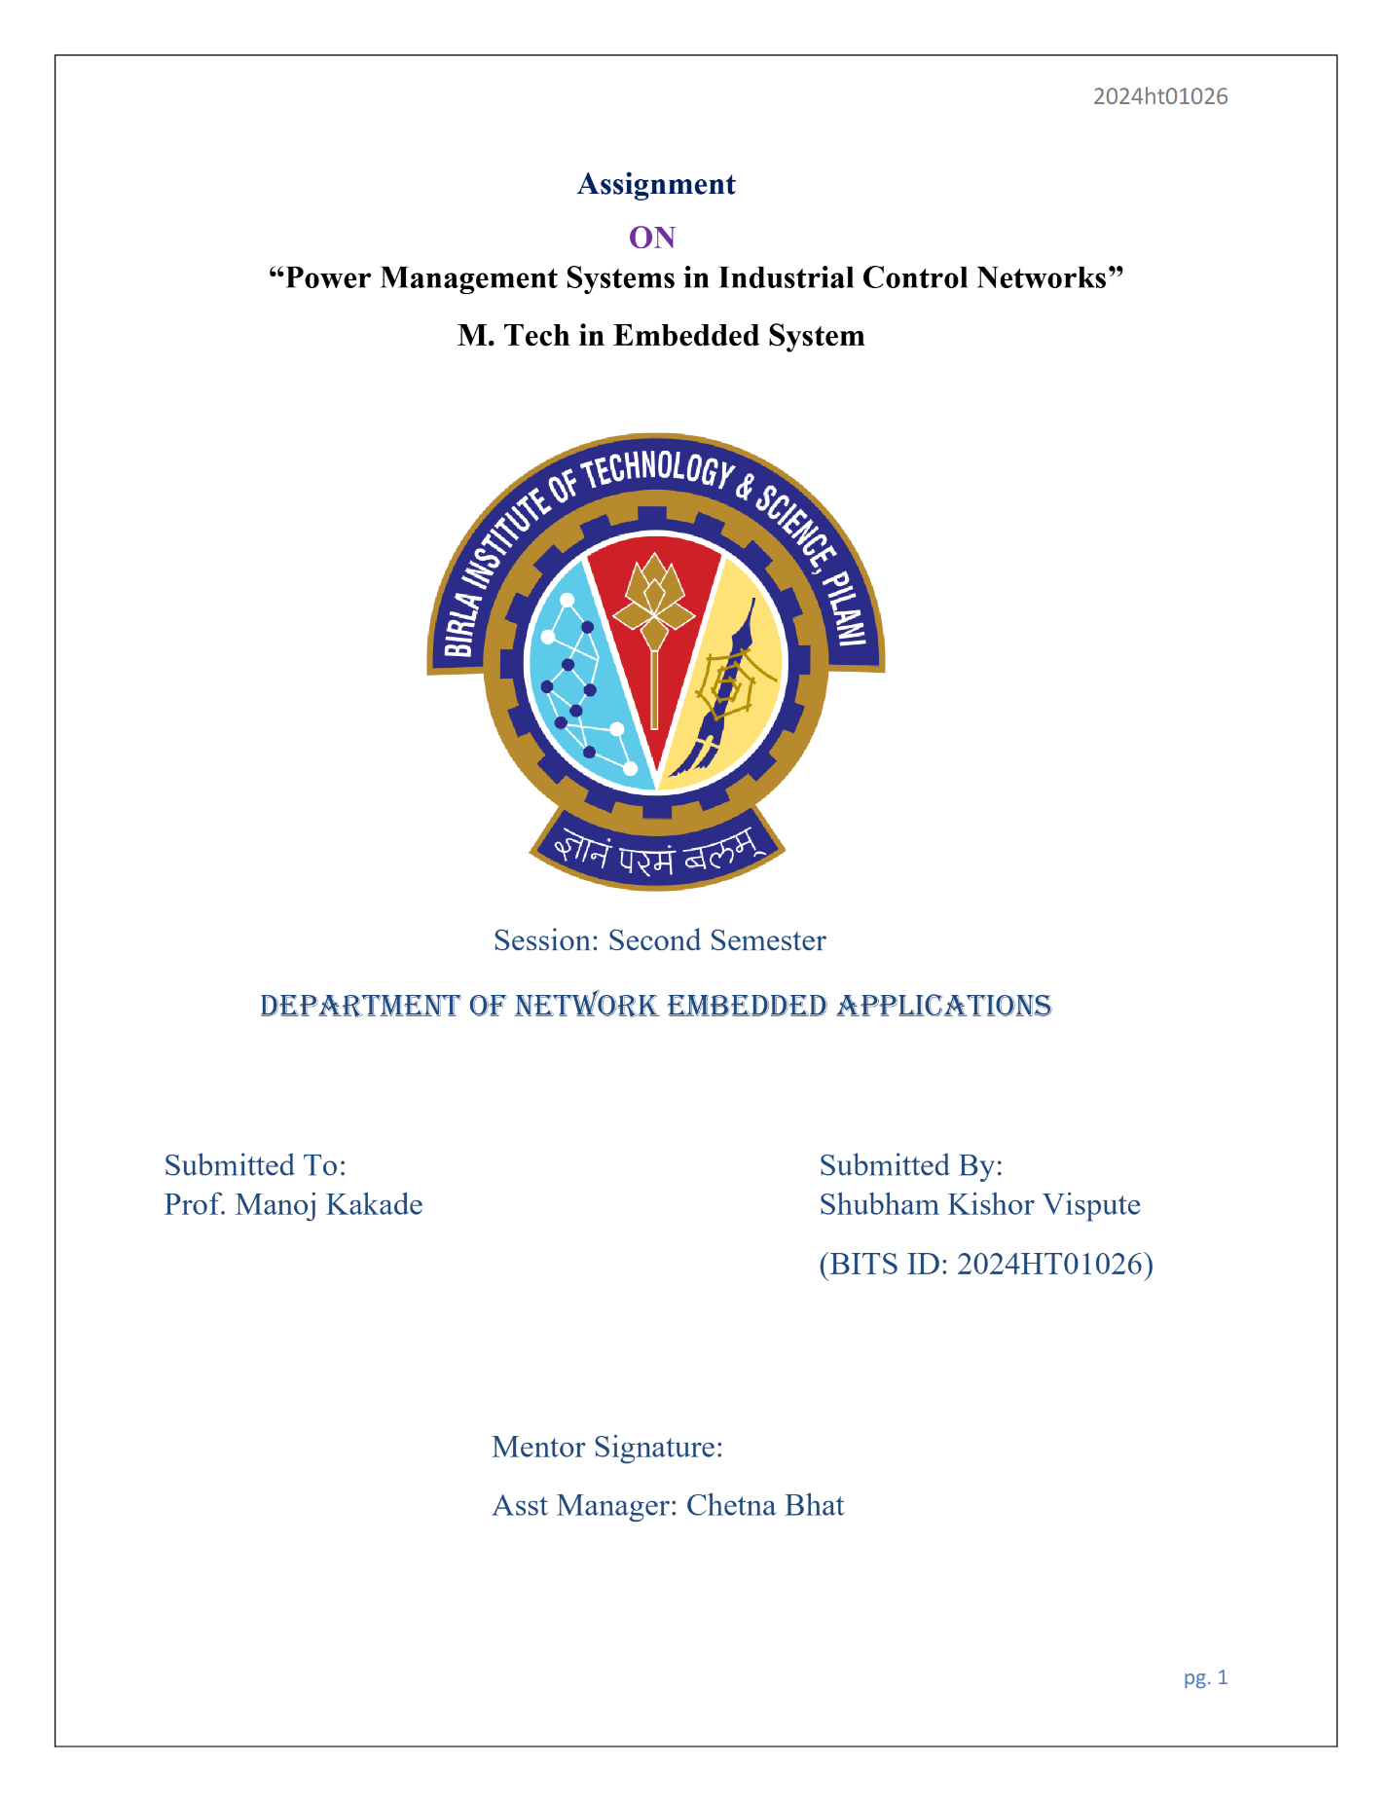

Submitted by:

**Name:** Mukund Vishwas Chavan

**Course:** Network Embedded Applications

**Student ID:** 01011

Submitted To:

**Prof. Manoj Kakade**



**Mentor Signature:**

**Dinesh Thant**

Senior Engineer - Embedded Development

Global Engineering Center, Pune.

Enhancing Power utilization with Industrial Control Networks

# Index

1. **Introduction**
2. **Literature Survey**
3. **Communication Protocol**
4. **Industry Applications**
5. **Case Study: Load Balancing with Carlo Gavazzi EM24 AC Meter**
6. **IoT Integration**
7. **Challenges**
8. **Conclusion**
9. **References**

* **Introduction**

This article explores the role of ICNs in enhancing power management. In the power sector, ICNs play a crucial role in enhancing power management by enabling real-time monitoring, control, and optimization of power systems. We will be looking into application of ICNs in power management is the use of advanced metering devices, such as the Carlo Gavazzi EM24 AC meter, to obtain real-time data and balance loads across phases. Phase balancing involves adjusting the loads on each phase of a three-phase system to ensure they are as equal as possible. Imbalances in phase loads can lead to increased losses, overheating, and reduced lifespan of electrical components. By leveraging ICNs, industries can achieve better phase balancing, thereby enhancing the stability and efficiency of power systems.

Phase balancing involves adjusting the loads on each phase of a three-phase system to ensure that they are as equal as possible. Imbalances can lead to increased losses, overheating, and reduced lifespan of electrical components. Various studies have highlighted the importance of phase balancing in maintaining the stability and efficiency of power systems.

Industrial Control Networks (ICNs) are essential in modern industrial environments, providing the necessary infrastructure required for monitoring and regulating physical processes. These networks are critical for improving efficiency, reliability, and security in a variety of industrial applications including as manufacturing, power production, water treatment, and transportation.   
ICNs are a collection of technologies and protocols that enable real-time data interchange and control amongst various components of an industrial setup. They provide for seamless communication between sensors, actuators, controllers, and supervisory systems, ensuring that industrial processes run smoothly and efficiently. The incorporation of ICNs into industrial operations has altered how companies manage and optimize their processes, resulting in considerable increases in productivity and operational efficiency.

* **Literature Survey**

Early research on Industrial Control Networks (ICNs) primarily focused on the fundamental principles and challenges associated with their deployment. This included the development of robust communication protocols, reliable network architectures, and efficient data aggregation techniques. Researchers aimed to address the limitations of control systems, such as limited processing power, communication range, and the need for real-time data exchange.

Recent advancements in ICNs have seen the integration of advanced algorithms, the Internet of Things (IoT), and the development of smart grid applications. These advancements have significantly enhanced the capabilities of ICNs, enabling more sophisticated data analysis, real-time monitoring, and improved scalability. For instance, the use of the Carlo Gavazzi EM24 AC meter in power management systems has enabled precise measurement and balancing of loads across phases, thereby improving overall system efficiency.

Despite significant progress in the development and application of ICNs, ongoing research is needed to address remaining challenges and further enhance the capabilities of these networks in industrial environments. Key areas of focus include improving energy efficiency, ensuring seamless communication and data aggregation in large-scale networks, and implementing robust security measures to protect against threats such as eavesdropping and data tampering.

* **Communication Protocols**

In our case we are using CAN protocol for communicating with Rectifier where Protocol between the supervision module and rectifier module and Rectifier to Rectifier Protocol. Modbus protocol for AC meter. Below is the short description of both the protocols

**CAN Protocol**

**Controller Area Network (CAN)** is a robust vehicle bus standard designed to enable microcontrollers and devices to communicate with each other without a host computer. Originally developed by Bosch in the 1980s for automotive applications, CAN has since been adopted in various other industries, including industrial automation, medical equipment, and more.

CAN is a message-based protocol, meaning that data is transmitted in packets called messages. Each message contains an identifier that indicates the priority of the message.

Reliability: CAN ensures data integrity and prioritization through a process called arbitration, where the highest priority message is transmitted first if multiple devices attempt to send data simultaneously. The protocol includes error detection and fault confinement mechanisms, making it highly reliable in noisy environments.

Modbus RS485

Monitoring Device

AC Meter

CAN

Rectifier

**Modbus Protocol**

**Modbus** is a serial communication protocol developed by Modicon (now Schneider Electric) in 1979 for use with programmable logic controllers (PLCs). It has become a de facto standard communication protocol for connecting industrial electronic devices.

Modbus operates on a client-server (or master-slave) architecture. The client (or master) requests information, and the server (or slave) responds with the requested data. Modbus supports communication over various physical layers, including serial lines (Modbus RTU and Modbus ASCII) and Ethernet (Modbus TCP)

**Benefits of Load Balancing**

Reduces Energy Losses: Balanced loads minimize I²R losses, improving energy efficiency.

Prevents Equipment Damage: Even load distribution prevents overheating and extends the lifespan of electrical components.

Enhances Power Quality: Balanced loads reduce voltage fluctuations and improve power supply stability.

Maximizes Efficiency: Ensures transformers and distribution networks operate within their optimal range, reducing operational costs.

Phase balancing process involves:

Measurement: The EM24 meter measures the current in each phase, providing real-time data on load distribution.

Analysis: The data is analyzed to identify imbalances in the load distribution across phases.

Redistribution: Loads are redistributed to ensure each phase carries an approximately equal amount of load, reducing inefficiencies and preventing equipment damage.

Verification: The balanced load distribution is verified by monitoring the neutral current and ensuring it remains within acceptable limits.

* **Industry Applications of Industrial Control Networks**

This section explores the specific applications of ICNs in power management, with a focus on the use of the Carlo Gavazzi EM24 AC meter for load balancing.

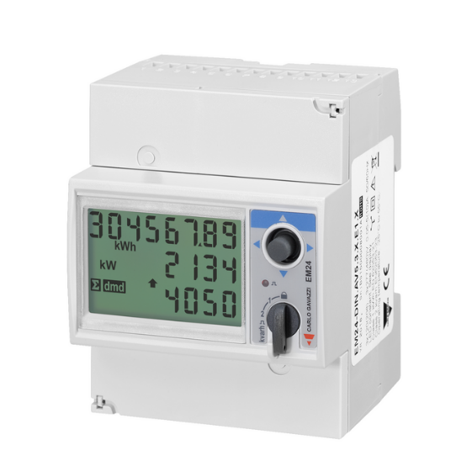

**Grid Monitoring and Management**: ICNs enable real-time monitoring and control of power grids, ensuring stable and efficient operation. By integrating sensors and control devices, ICNs provide detailed insights into grid performance, helping operators detect and respond to faults quickly. This real-time data is essential for maintaining grid stability and preventing outage.

**Smart Metering**: Smart meters, connected through ICNs, provide detailed consumption data to both utilities and consumers. This data helps in better demand forecasting, dynamic pricing, and energy conservation. The Carlo Gavazzi EM24 AC meter, for example, can measure various electrical parameters and communicate this data to central control systems, facilitating efficient energy management.

**Renewable Energy Integration:** The integration of renewable energy sources, such as solar and wind, into the power grid is a complex task that requires precise control and monitoring. ICNs support this integration by providing real-time data on energy production and consumption, ensuring that renewable energy is efficiently distributed and utilized. This helps in maintaining grid stability and optimizing the use of renewable resources.

* **Case Study: Load Balancing with Carlo Gavazzi EM24 AC Meter**

In our power management system, The Carlo Gavazzi EM24 AC meter plays a pivotal role in achieving this balance by providing precise measurements and real-time data on load distribution. This case study explores the process and benefits of using the EM24 meter for load balancing in an industrial setting.

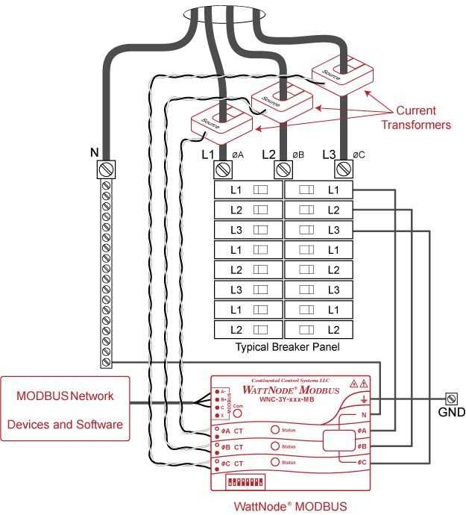

**Measurement and Data Collection**

The Carlo Gavazzi EM24 AC meter is a three-phase energy analyzer designed for DIN-rail mounting. It features a configuration joystick, frontal selector, and LCD display, allowing for easy setup and operation. The meter can directly connect to 65A or via current transformers for higher currents. It measures various electrical parameters, including voltage, current, power, and energy consumption.

**Load Balancing Process**

1. **Measurement**: The EM24 meter measures the current in each phase, providing real-time data on load distribution. This data is crucial for identifying imbalances and taking corrective actions.
2. **Data Analysis**: The collected data is analyzed to determine the load distribution across phases. Any significant imbalances are flagged for further action.
3. **Redistribution**: Based on the analysis, loads are redistributed to ensure each phase carries an approximately equal amount of load. This process involves adjusting the connections and load assignments to achieve balance.
4. **Verification**: The balanced load distribution is verified by monitoring the neutral current and ensuring it remains within acceptable limits. Continuous monitoring helps maintain the balance over time.

The Carlo Gavazzi EM24 AC meter is an invaluable tool for load balancing in industrial power management systems. Its precise measurements and real-time data capabilities enable effective monitoring and control of load distribution, leading to enhanced efficiency, reliability, and safety. As industrial systems continue to evolve, the integration of advanced energy analyzers like the EM24 will play a crucial role in optimizing power management and ensuring sustainable operations.

* **IoT Integration**

The IoT Wireless Power Meter is designed to seamlessly integrate with IoT platforms, providing users with comprehensive energy management solutions. Here are some key aspects of its IoT integration:

**IoT Integration Process**

1. **Communication Gateway**: To enable IoT integration, a communication gateway such as a LoRaWAN or Modbus/TCP converter is used. This gateway facilitates the transmission of data from the EM24 meter to the IoT platform.
2. **Data Transmission**: The gateway sends the collected data to an IoT platform using wireless communication protocols. For instance, a LoRaWAN gateway can transmit data over long distances with low power consumption, making it ideal for remote monitoring.
3. **IoT Platform Integration**: The data is received by the IoT platform, where it is processed and analyzed. Popular IoT platforms like Azure IoT Central and ThingsBoard can be used to create custom dashboards for real-time monitoring and analysis.
4. **Data Visualization and Analysis**: The IoT platform provides tools for visualizing the data through interactive dashboards. Users can monitor key metrics, set alerts for abnormal conditions, and generate reports for further analysis.

**Benefits of IoT Integration**

* **Real-Time Monitoring**: Continuous real-time monitoring of electrical parameters allows for immediate detection of anomalies and prompt corrective actions.
* **Enhanced Data Analysis:** Advanced analytics tools on IoT platforms can process large volumes of data, providing valuable insights into system performance and efficiency.
* **Maintenance:** By analyzing historical data, IoT platforms can predict potential failures and schedule maintenance activities proactively, reducing downtime and maintenance costs.
* **Scalability:** IoT integration makes it easy to scale the monitoring system by adding more devices and sensors as needed, without significant infrastructure changes.
* **Improved Energy Management**: The real-time data provided by the IoT Wireless Power Meter helps optimize energy consumption, reduce costs, and enhance overall system efficiency.

 IoT integration enables continuous real-time monitoring of electrical parameters, allowing for immediate detection of anomalies and prompt corrective actions. IoT integration allows for remote access to the EM24 meter's data, enabling operators to monitor and manage the system from anywhere. advanced analytics tools on IoT platforms can process large volumes of data, providing valuable insights into system performance and efficiency.

* **Challenges**

Despite their numerous advantages we can face several challenges:

**Data Accuracy and Reliability**: Ensuring precise measurements from the EM24 meter is crucial for effective load balancing and energy management. Accurate data is essential to identify imbalances and make informed decisions. Any discrepancies in measurements can lead to incorrect load redistribution, potentially causing inefficiencies and equipment damage.

**Communication Protocols:** Integrating Modbus for the AC meter and CAN for rectifier communication can be complex, requiring careful configuration and management. Compatibility issues and data synchronization between different protocols can pose significant challenges. Ensuring seamless communication between these protocols is vital for the smooth operation of the control network

**Energy Consumption:** Managing the overall energy usage of the ICN, including sensors and communication devices, is essential to balance benefits and costs. The continuous operation of these devices can lead to increased energy consumption. Implementing energy-efficient strategies and optimizing the power usage of network components are necessary to maintain a sustainable system

**Scalability**: As systems grow, maintaining performance while adding more devices and sensors to the network can be challenging. Scalability issues can arise from the increased data load and the need for more robust communication infrastructure. Ensuring that the ICN can scale effectively without compromising performance is crucial for long-term success

**Integration with Existing Systems:** Ensuring compatibility and seamless integration with existing industrial systems often requires customized solutions. This involves addressing compatibility issues, data integration, and system interoperability. The integration process can be complex and time-consuming, requiring careful planning and execution.

**Maintenance and Troubleshooting:** Regular maintenance and prompt issue resolution are necessary to prevent disruptions in power management. Industrial control networks require ongoing monitoring and maintenance to ensure optimal performance. Troubleshooting issues can be complex, especially in large-scale systems, and requires skilled personnel to identify and resolve problems efficiently

* **Conclusion**

The integration of Industrial Control Networks (ICNs) with advanced devices like the Carlo Gavazzi EM24 AC meter significantly enhances power management in industrial settings. By leveraging robust communication protocols such as CAN for rectifier communication and Modbus for AC meters, ICNs facilitate precise monitoring, real-time data exchange, and efficient load balancing. These capabilities lead to improved energy efficiency, reduced operational costs, and enhanced system reliability.

Despite the numerous benefits, several challenges must be addressed to fully realize the potential of ICNs. Ensuring data accuracy and reliability, managing energy consumption, and maintaining scalability are critical for the successful deployment of these networks. Additionally, robust security measures are essential to protect against potential threats and ensure the integrity of the system.

The case study on load balancing using the Carlo Gavazzi EM24 AC meter demonstrates the practical benefits of ICNs in power management. By providing real-time data and enabling automated load redistribution, the EM24 meter helps optimize energy use and prevent equipment damage. The integration of IoT technologies further enhances these capabilities, allowing for remote monitoring, predictive maintenance, and advanced data analysis.

As technology continues to evolve, the role of ICNs in industrial automation and power management will become increasingly vital. Ongoing research and development are necessary to address the remaining challenges and unlock new opportunities for innovation. By embracing these advancements, industries can achieve greater efficiency, sustainability, and resilience in their operations.

* **References**

1. "Energy analyzer for three-phase systems," Carlo Gavazzi Controls S.p.A., 2020. (https://gavazzi.se/wp-content/uploads/2020/11/em24_ds_eng.pdf)

2. "Modbus with Carlo Gavazzi EM24 - Home Assistant Community," 2023. (https://community.home-assistant.io/t/modbus-with-carlo-gavazzi-em24/353336)

3. "Energy management controllers: strategies, coordination, and applications," Energy Informatics, 2024. (https://energyinformatics.springeropen.com/articles/10.1186/s42162-024-00357-9)

4. "Industrial networking 101: Everything you need to know," Control Engineering, 2024. (https://www.controleng.com/industrial-networking-101-everything-you-need-to-know/)